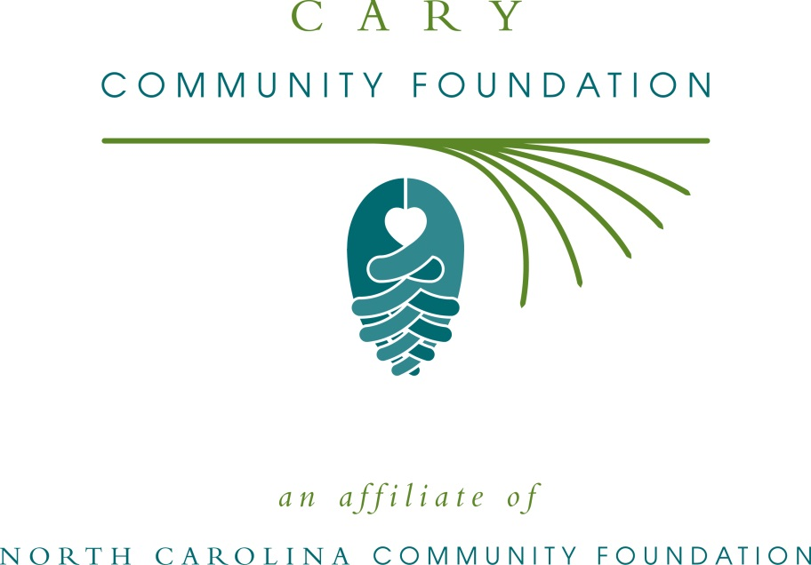
Cary Community Foundation accepting grant applications
For immediate release -- 6/27/16
The board of advisors of the Cary Community Foundation is currently accepting grant requests for projects funded from its community grantmaking fund, according to Laird Hepburn, board president.
Funds are available for nonprofit organizations that serve general charitable needs in Cary. Applications are available beginning July 1. Visit nccommunityfoundation.org for information about applying. The deadline for submitting applications is noon Aug. 2.
The Cary Community Foundation is an affiliate of the North Carolina Community Foundation. The community fund was established to help support local charitable needs through annual grants. In addition to Hepburn, board members are: Travis Wright Colopy, Debbie Fox, Laura Martin and Bharat Vedak.
For further information, contact NCCF Regional Director Katie Crumpler at kcrumpler@nccommunityfoundation.org or 919-256-6914 or visit the NCCF website at nccommunityfoundation.org.
About the North Carolina Community Foundation
The NCCF is the single statewide community foundation serving North Carolina and has made $101 million in grants since its inception in 1988. With more than $237 million in assets, NCCF sustains 1,200 endowments established to provide long-term support of a broad range of community needs, nonprofit organizations, institutions and scholarships. The NCCF partners with 60 affiliate foundations to provide local resource allocation and community assistance in 67 counties across the state. An important component of NCCF’s mission is to ensure that rural philanthropy has a voice at local, regional and national levels.
For more information, visit nccommunityfoundation.org, like us on Facebook and follow us on LinkedIn and Twitter @NCCF.
Media contact
Katie Crumpler; NCCF Regional Director
919-256-6914; kcrumpler@nccommunityfoundation.org

