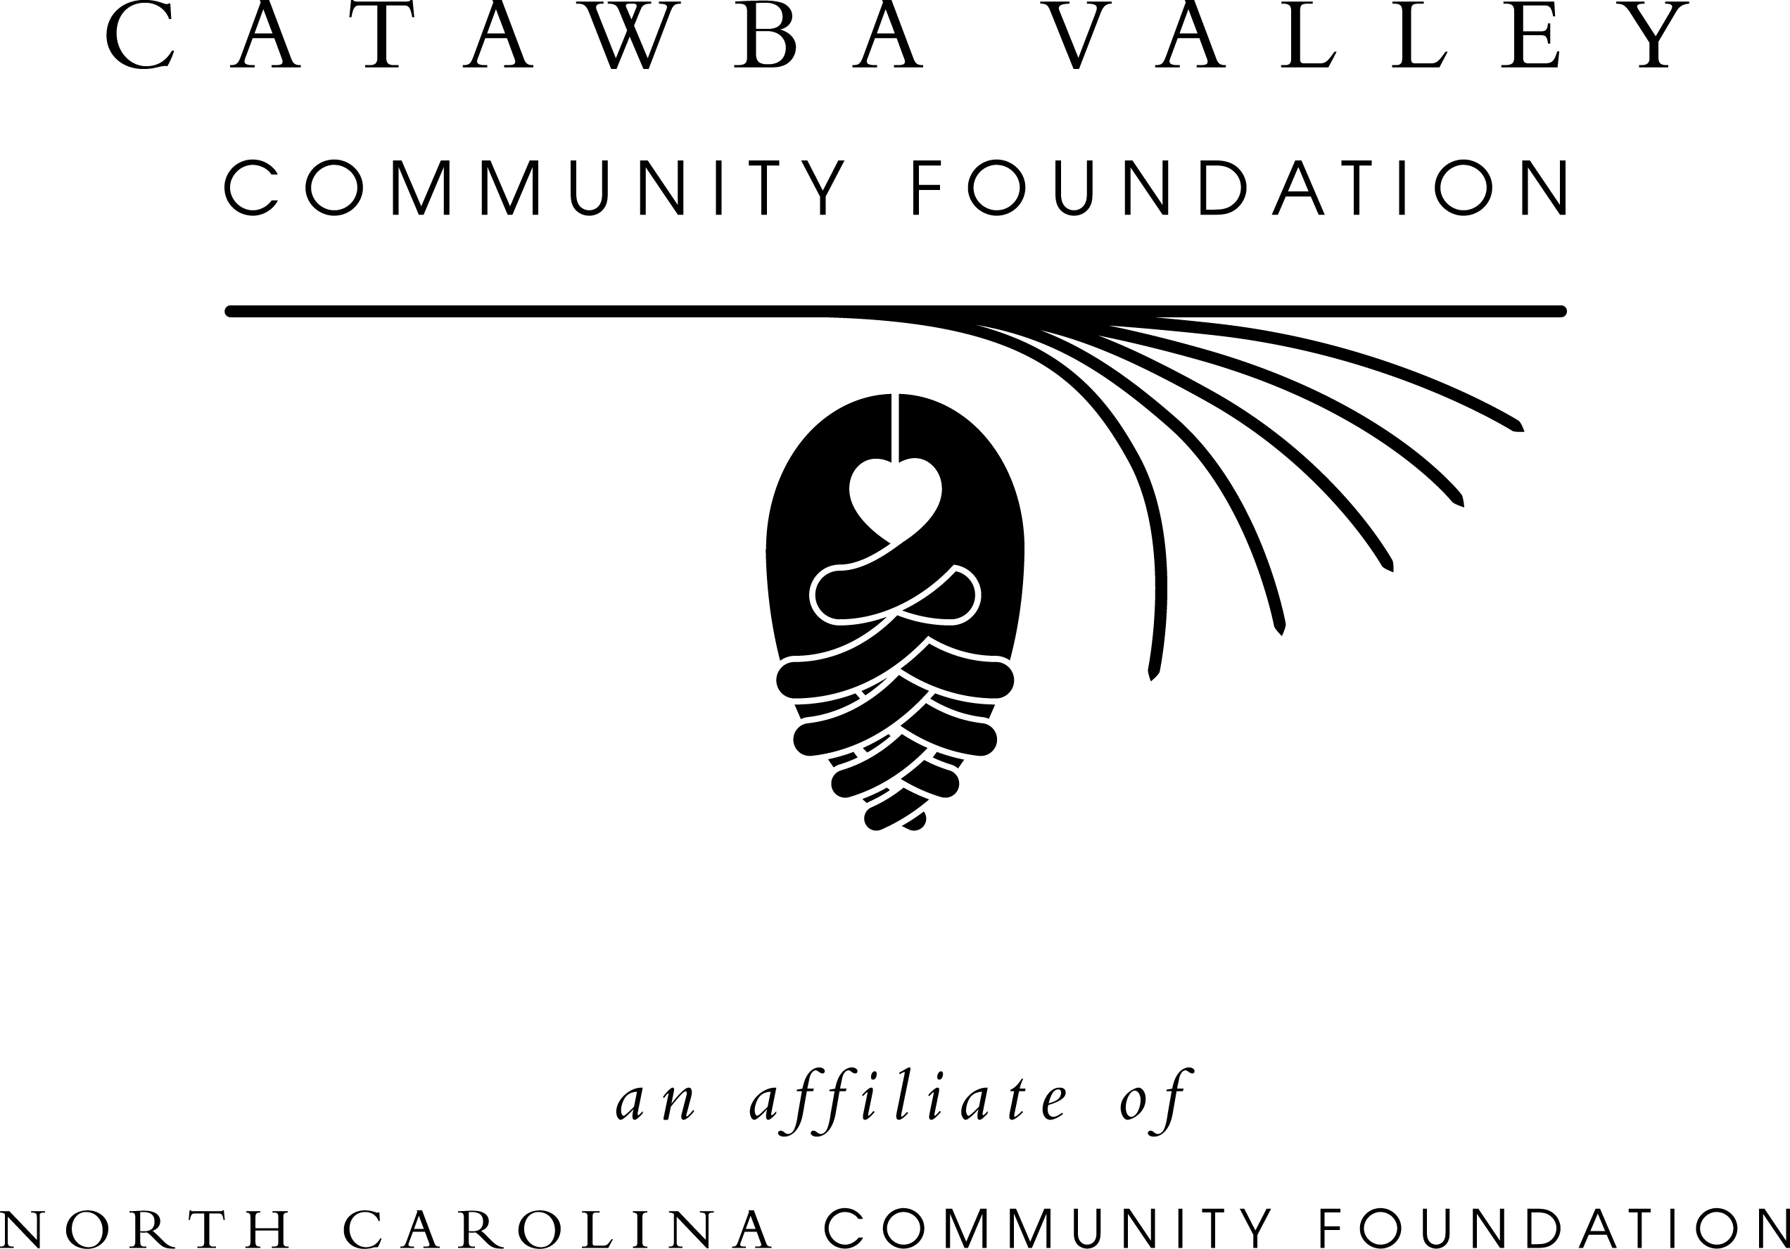
Catawba Valley Community Foundation moves to new office space in Hickory
Oct. 30, 2014 -- For immediate release
HICKORY – The Catawba Valley Community Foundation (CVCF) has moved to new offices in the Lyerly House at 310 N. Center St. in Hickory, 28601, according to an announcement by John Francis, NCCF regional associate in charge of this area. He will work out of the new office location.
The CVCF’s mailing address will remain the same: P.O. Box 2851, Hickory, NC 28603. The office’s toll-free phone number remains 888-375-8117, and Francis also can be reached at 336-745-1739.
The CVCF’s previous office at 13th Avenue NE has been sold. Proceeds from the sale will go to the Unifour Foundation Endowment, which is held by the CVCF. The Unifour Foundation Endowment is CVCF’s largest grantmaking fund and has contributed more than $3 million to the Catawba Valley area.
The CVCF covers Alexander, Caldwell and Catawba counties and was founded in 1997. It is an affiliate of the North Carolina Community Foundation (NCCF).
About the North Carolina Community Foundation:
The NCCF is the single statewide community foundation serving North Carolina and has made $89 million in grants since its inception in 1988. With more than $191 million in assets, NCCF sustains 1,200 endowments established to provide long-term support of a broad range of community needs, nonprofit organizations, institutions and scholarships. The NCCF partners with 60 affiliate foundations to provide local resource allocation and community assistance in 67 counties across the state. An important component of NCCF’s mission is to ensure that rural philanthropy has a voice at local, regional and national levels. For more information, visit nccommunityfoundation.org and Facebook or follow on Twitter @NCCF.
MEDIA CONTACT:
John Francis
jfrancis@nccommunityfoundation.org
336-745-1739

