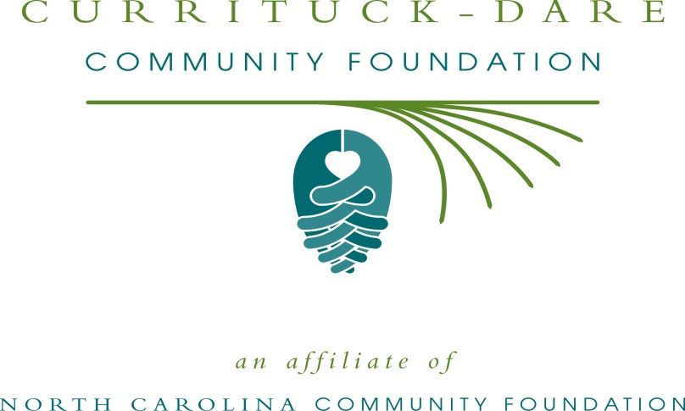
New environmental education fund awards first grant
For immediate release: October 20, 2014
An endowment to support charitable endeavors in the fields of coastal scientific research and environmental education in North Carolina's northeastern counties recently awarded its first grant, according to Bill and Peggy Birkemeier, who founded the fund; and Janet Colegrove, president of the Currituck-Dare Community Foundation (CDCF), which helped with the selection process. CDCF is an affiliate of the North Carolina Community Foundation (NCCF).
This year’s grant recipient from the Northeastern NC Coastal Research and Environmental Education Fund is the UNC Coastal Studies Institute for the Capstone Oyster Mariculture Research project.
About the Northeastern NC Coastal Research and Environmental Education Fund:
Bill, retired from the US Army Corps of Engineers, and Peggy, retired from NCCF, created the fund to reflect their shared love, interest and appreciation for the challenges of the coastal environment.
The grant was available for project or environmental education outreach efforts in one the following counties: Beaufort, Bertie, Camden, Chowan, Currituck, Dare, Gates, Hertford, Hyde, Martin, Pasquotank, Perquimans, Tyrrell or Washington.
The annual grants process will be announced next summer, and the application will be available at that time online at nccommunityfoundation.org on the CDCF affiliate page.
About the North Carolina Community Foundation
The NCCF is the single statewide community foundation serving North Carolina and has made $89 million in grants since its inception in 1988. With more than $191 million in assets, NCCF sustains 1,200 endowments established to provide long-term support of a broad range of community needs, nonprofit organizations, institutions and scholarships. The NCCF partners with 60 affiliate foundations to provide local resource allocation and community assistance in 67 counties across the state. An important component of NCCF’s mission is to ensure that rural philanthropy has a voice at local, regional and national levels. For more information, visit nccommunityfoundation.org and Facebook or follow on Twitter @NCCF.
END
News media contact: Natalie Jenkins Peel, NCCF Regional Associate, npeel@nccommunityfoundaiton.org; 252-216-8908
Photo ID’s for cutline: Bill Birkemeier, Dr. Andy Keeler, Program Head, Public Policy and Coastal Sustainability UNC Coastal Studies Institute; Students: Jerome Allen, Charlotte McEwen, John St. Clair (Camden County student), Michaela Meredith, Dakota Koenigsberg, and Quinton Grady. The students this semester are all from North Carolina and are enrolled full-time at the Institute for the Environment at UNC-Chapel Hill

