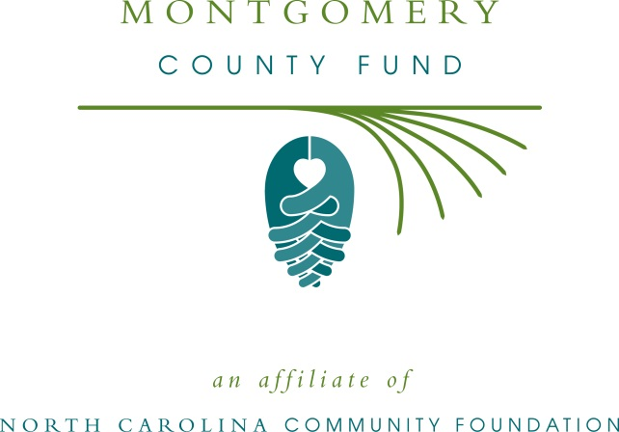

FOR IMMEDIATE RELEASE – 06/10/15

Montgomery County Fund awards local grants

The board of advisors of the Montgomery County Fund announces 2015 awards totaling $40,780, according to Judy Stevens, board president.

This year’s nonprofit recipients of $23,480 from the community grantmaking fund include:
- American Red Cross
- Central NC Council, Boy Scouts of America
- Communities in Schools of Montgomery County
- Montgomery County 4-H
- Montgomery County Cooperative Extension
- Montgomery County Council on Aging Inc.
- Montgomery County Partnership for Children
- Montgomery County Schools
- NC Cooperative Extension
- Star History Museum Organization

Additionally, other local fundholders who hold endowments with the Montgomery County affiliate provided support totaling another $17,300 to nonprofit recipients including:
- Highland Community Center
- Montgomery County Partnership for Children
- Piedmont Arts Guild of Mount Gilead
- Prevent Blindness North Carolina

Stevens thanked the community for support of the Montgomery County Fund. “These grants are important to our community and our quality of life,” she said. “Critical programs would not be possible without the generosity of many individuals, especially our local fundholders and organizations that support Montgomery County’s fund.”

The Montgomery County Fund is an affiliate of the North Carolina Community Foundation. Tax-deductible contributions can be made to the Montgomery County Fund, which is administered by the NCCF. Contributions should be made payable to the Montgomery County Fund and mailed to the North Carolina Community Foundation, Landmark Center, 4601 Six Forks Road, Suite 524, Raleigh, NC 27609. Contributions can also be made online at www.nccommunityfoundation.org.

For information on the Montgomery County Fund, contact Mary Anne Howard, regional associate, at 919-256-6924; or visit the NCCF website at www.nccommunityfoundation.org and click on “Affiliates.”

About the North Carolina Community Foundation

The NCCF is the single statewide community foundation serving North Carolina and has made $89 million in grants since its inception in 1988. With more than $191 million in assets, NCCF sustains 1,200 endowments established to provide long-term support of a broad range of community needs, nonprofit organizations, institutions and scholarships. The NCCF partners with 60 affiliate foundations to provide local resource allocation and community assistance in 67 counties across the state. An important component of NCCF’s mission is to ensure that rural philanthropy has a voice at local, regional and national levels.

For more information, visit nccommunityfoundation.org and Facebook or follow on LinkedIn and Twitter @NCCF.
# # #
NEWS MEDIA CONTACTS:

Mary Anne Howard, NCCF Regional Associate
919-256-6924; mhoward@nccommunityfoundation.org

Noel McLaughlin, NCCF Director, Marketing and Communications
919-256-6901; nmclaughlin@nccommunityfoundation.org

