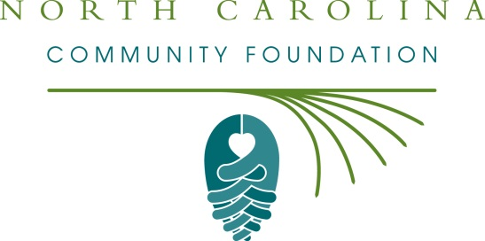

FOR IMMEDIATE RELEASE – 6/16/15
Morrisville Community Fund accepting grant applications
The board of advisors of the Morrisville Community Fund is currently accepting grant requests for community projects funded from its community fund, according to Liz Johnson, board chair.
Funds are available for nonprofit organizations and governmental entities that serve general charitable needs in the Town of Morrisville. Applications are available online only beginning June 26. For information about applying online, visit nccommunityfoundation.org. The deadline for submitting applications is noon, Aug. 11.
The Morrisville Community Fund is under the umbrella of the North Carolina Community Foundation. The community fund was established to help support local charitable needs through annual grants.
For further information, email Katie Crumpler, NCCF regional associate, at kcrumpler@nccommunityfoundation.org or call her at 919-256-6914.
About the North Carolina Community Foundation
The NCCF is the single statewide community foundation serving North Carolina and has made $89 million in grants since its inception in 1988. With more than $191 million in assets, NCCF sustains 1,200 endowments established to provide long-term support of a broad range of community needs, nonprofit organizations, institutions and scholarships. The NCCF partners with 60 affiliate foundations to provide local resource allocation and community assistance in 67 counties across the state. An important component of NCCF’s mission is to ensure that rural philanthropy has a voice at local, regional and national levels.
For more information, visit nccommunityfoundation.org and Facebook or follow on Twitter @NCCF.
###
News Media Contacts:
Katie Crumpler
NCCF Regional Associate
919-256-6914
kcrumpler@nccommunityfoundation.org
Noel McLaughlin
NCCF Director, Marketing and Communications
919-256-6901
nmclaughlin@nccommunityfoundation.org

