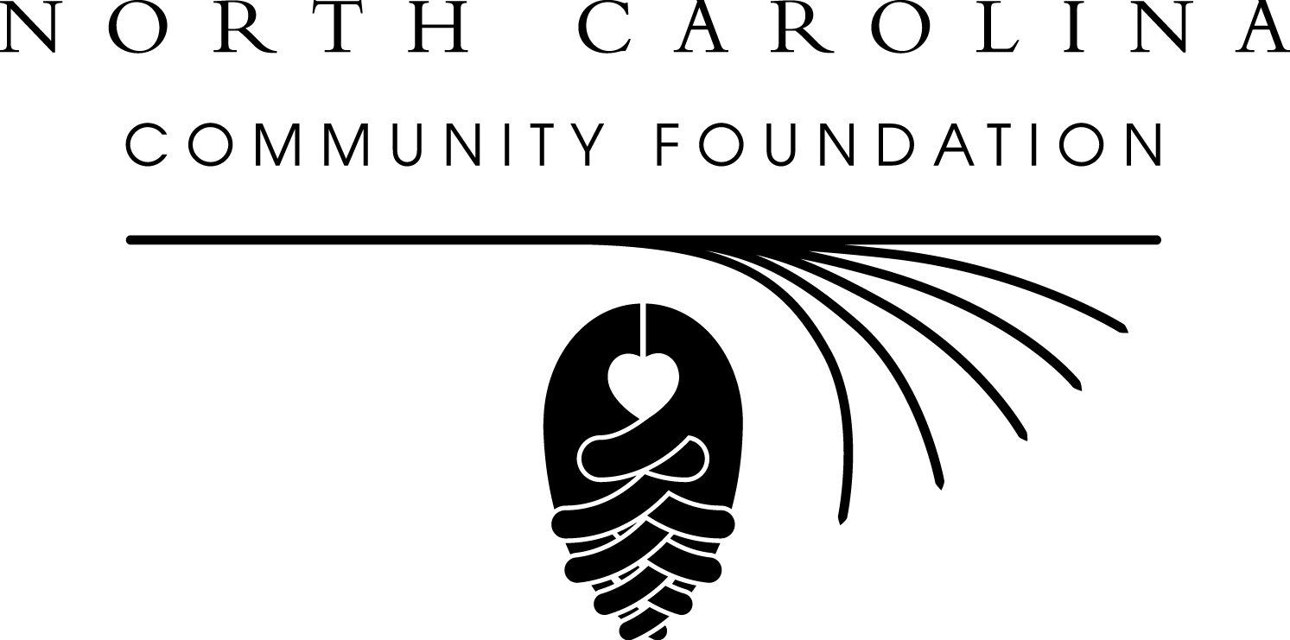

March 17, 2014

**NEW HANOVER COUNTY COMMUNITY FOUNDATION ANNOUNCES**

**TWO NEW SCHOLARSHIPS**

The board of advisors of the New Hanover County Community Foundation announced the creation of two new scholarships that will support students in the fields of education and nursing.

Trustees for the estate of Joseph Bergin and Elsa Flower Davies, who retired to Wilmington in 1980, established the two scholarship endowments with the North Carolina Community Foundation late last year. Members of the New Hanover County Community Foundation board will serve on the scholarship committees and make award recommendations.

“It is an honor and a privilege for the New Hanover County Community Foundation to administer these two scholarship awards,” said Stephen Gaskins, board president.

“Joseph and Elsa Davies valued education and were major benefactors of The Davis Community in Porters Neck, where the Joseph B. and Elsa Flower Davies Wellness Center is named in their honor.

“These scholarships will support students who wish to pursue their degrees in New Hanover County, so the Davies’ philanthropy will continue to benefit our local community.”

Scholarships are available for students wishing to pursue a degree or training in the field of nursing or teaching at an institution of higher learning in New Hanover County, North Carolina. Application forms are available on the North Carolina Community Foundation’s website, www.nccommunityfoundation.org. Complete application packets must be postmarked by Friday, April 25. The review committee will not consider incomplete applications.

The New Hanover County Community Foundation is an affiliate of the North Carolina Community Foundation. In 2013, the New Hanover affiliate and local fund holders made more than $1.2 million in grants to charitable organizations.

In addition to Board President Stephen Gaskins, New Hanover County Community Foundation board members are: Ned Barclay, Patrick Boykin, Ron Copley, Eldridge Dodson, Noel Fox, Frank Gibson, Rickey Godwin, Betty McComas, Patrick Moore, Kristi Sullivan and George Taylor

For further information, contact Patricia Lawler, NC Community Foundation Southeast Region Associate, at [plawler@nccommunityfoundation.org](mailto:plawler@nccommunityfoundation.org) or 910-509-7256.

**About the North Carolina Community Foundation:**

The NCCF is the single statewide community foundation serving North Carolina and has made nearly $74 million in grants since its inception in 1988. With more than $171 million in assets, NCCF sustains 1,200 endowments established to provide long-term support of a broad range of community needs, nonprofit organizations, institutions and scholarships. The NCCF partners with 60 affiliate foundations to provide local resource allocation and community assistance in 67 counties across the state. An important component of NCCF’s mission is to ensure that rural philanthropy has a voice at local, regional and national levels.

For more information, visit nccommunityfoundation.org and Facebook or follow on Twitter @NCCF

.# # #

NEWS MEDIA CONTACTS:

Patricia Lawler, Regional Associate

NC Community Foundation

910-509-7256

plawler@nccommunityfoundation.org

Noel McLaughlin, Director, Marketing and Communications

North Carolina Community Foundation

919.256-6901

nmclaughlin@nccommunityfoundation.org