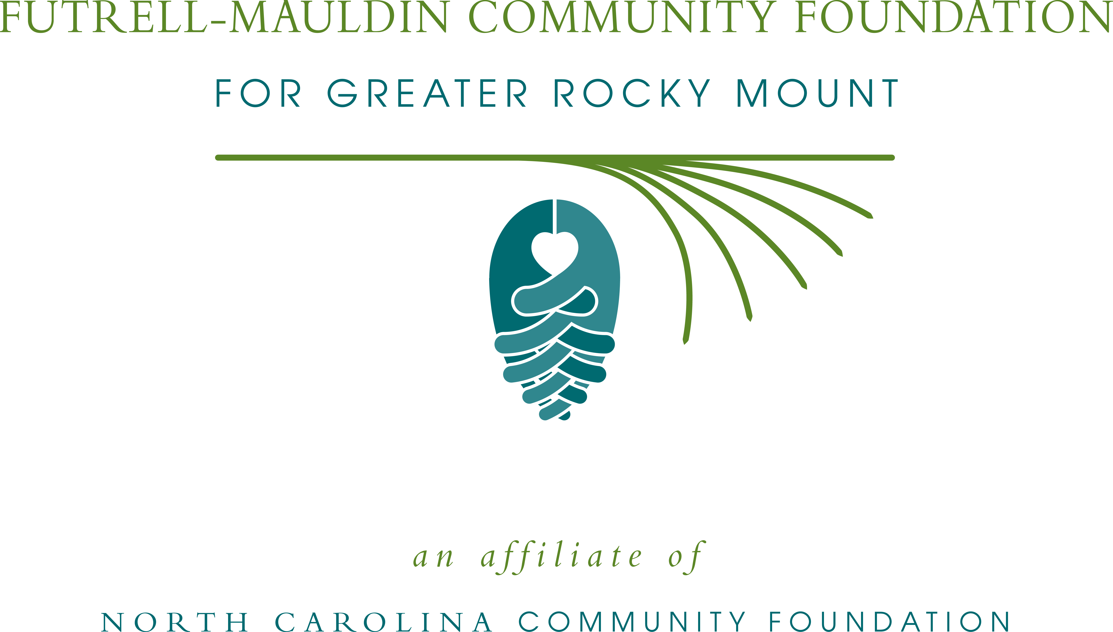

Futrell-Mauldin Community Foundation offers July 8th workshop for nonprofits
What: Futrell-Mauldin Community Foundation workshop to demonstrate the online grants application process
When: Tuesday, July 8, 9:30 a.m.
Where: The Gateway Technology Center, 3400 N. Wesleyan Blvd., Rocky Mount
Additional information:
- Seating is limited; RSVP by July 3rd to klee@nccommunityfoundation.org
- For further information, contact Kelly Lee, NCCF regional associate at 252-973-1205 or email klee@nccommunityfoundation.org

About the North Carolina Community Foundation:
The NCCF is the single statewide community foundation serving North Carolina and has made nearly $74 million in grants since its inception in 1988. With more than $171 million in assets, NCCF sustains 1,200 endowments established to provide long-term support of a broad range of community needs, nonprofit organizations, institutions and scholarships. The NCCF partners with 60 affiliate foundations to provide local resource allocation and community assistance in 67 counties across the state. An important component of NCCF’s mission is to ensure that rural philanthropy has a voice at local, regional and national levels.
For more information, visit www.nccommunityfoundation.org and Facebook or follow on Twitter@NCCF.

NEWS MEDIA CONTACTS:
Kelly Lee, 252-973-1205
klee@nccommunityfoundation.org

