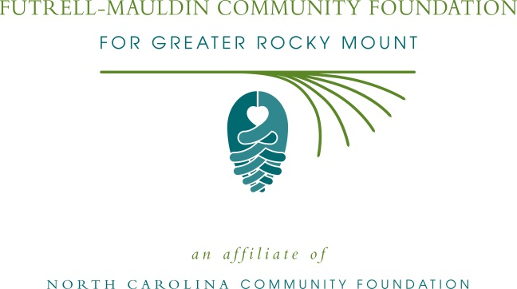
Futrell-Mauldin Community Foundation for Greater Rocky Mount
announces partnership with Davenport Autopark

The board of directors of the Futrell-Mauldin Community Foundation for Greater Rocky Mount is pleased to announce a new, ongoing funding partnership with Davenport Autopark.
As part of its “Community for Life” community reinvestment initiative, Davenport Autopark will contribute to the Futrell-Mauldin Community Foundation’s endowment for annual grantmaking to nonprofits serving the Nash County area. Contributions will be made through the sale of new and pre-owned vehicles to Davenport customers who enroll in the Dealership for Life membership plan. A portion of the enrollment fee paid by Davenport will be directed to the Foundation.
“We feel that this is a great way to support the local community that supports us,” said Davenport President Neill Nelson. “The Foundation’s grants process is open to a wide variety of nonprofit organizations, and multiple recipients may be chosen in any given year,” he added. “That kind of broad community outreach appeals to our company and to our customers.”
Sam Johnson, president of the Futrell-Mauldin Community Foundation’s board of advisors, said he and the board were gratified for this new support of the local grantmaking program. “Davenport Autopark is well-known as a company that gives back, and this innovative contribution program will help our Foundation support a variety of causes that are important to our community,” he said.
Davenport originally launched its “Community for Life” initiative in partnership with “Reach Out Rocky Mount,” contributing more than $55,000 in the five years that Reach Out Rocky Mount was active.
About Davenport Autopark
Davenport, which has served the automotive needs of the Rocky Mount community and surrounding areas for over 85 years, has an A+ rating with the Better Business Bureau, and has been voted “Best Automotive Dealership” in the Rocky Mount Telegram’s Readers’ Choice competition for each of the past five years. Davenport was started downtown in 1929 by the late David W. Davenport as a Pontiac-Oakland dealership, and is now operated by his son-in-law Joe Nelson, Grandson Neill Nelson, and Great-grandson Graham Nelson as an autopark housing Buick-GMC and Honda dealerships as well as a center for Pre-owned vehicles of all types.
About the Futrell-Mauldin Community Foundation of Greater Rocky Mount
The Futrell-Mauldin Community Foundation is an affiliate of the North Carolina Community Foundation (NCCF). Futrell-Mauldin has awarded more than $650,000 to nonprofits serving the Greater Rocky Mount area since its inception in 1997. The Foundation sponsors an annual, competitive grants cycle for local nonprofit organizations. This year’s grants cycle will run from July 3-Aug. 18, with information and applications available online at nccommunityfoundation.org. Visit the Futrell-Mauldin page at that web address to learn more about the Futrell-Mauldin Community Foundation.
About the North Carolina Community Foundation
The NCCF is the single statewide community foundation serving North Carolina and has made nearly $89 million in grants since its inception in 1988. With more than $191 million in assets, NCCF sustains 1,200 endowments established to provide long-term support of a broad range of community needs, nonprofit organizations, institutions and scholarships. The NCCF partners with 60 affiliate foundations to provide local resource allocation and community assistance in 67 counties across the state. An important component of NCCF’s mission is to ensure that rural philanthropy has a voice at local, regional and national levels.
For more information, visit nccommunityfoundation.org and Facebook or follow on LinkedIn and Twitter @NCCF.
END
News media contact:
Kelly Lee, NCCF Regional Associate, Coastal Plain North
klee@nccommunityfoundation.org
252-245-1794

