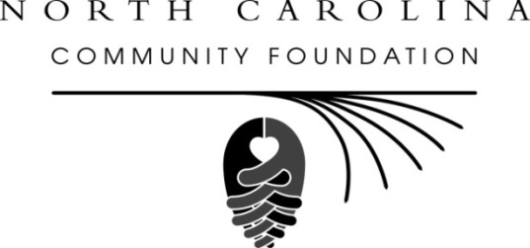
North Carolina Community Foundation receives $20 million
endowment from estate of Louise Oriole Burevitch
Feb. 2, 2015 – For immediate release
RALEIGH -- The North Carolina Community Foundation (NCCF) has been named administrator of a $20 million endowment resulting from the planned giving legacy of noted Wilmington, NC philanthropist Louise Oriole Burevitch, according to an announcement made by Jennifer Tolle Whiteside, NCCF CEO and president.
Tolle Whiteside said the endowment would have a “transformative effect” on eastern North Carolina and many of the causes important to Burevitch. “Endowment gifts of this size are truly a permanent asset, not only for local communities, but in many cases entire regions,” she said. “Mrs. Burevitch’s legacy will be felt throughout the entire eastern North Carolina region for generations to come.”
Burevitch died at the age of 97 in September of 2014, and soon thereafter NCCF was notified of the bequest to the endowment it had already established in 2008 at her direction.
NCCF Vice President of Development Beth Boney Jenkins had worked with Burevitch for many years on philanthropic matters and said her charitable interests were wide-ranging, with a primary focus on animal causes, education initiatives and support of women and children. “Mrs. B, as we called her, loved people and animals, which was evident not only in her charitable giving, but also in the legions of friends and admirers she had,” Jenkins said. “She never met a stranger.”
NCCF is in the process of establishing a grants committee that will administer a grants program for the areas of interest identified by Burevitch. The committee is expected to be named by the summer of 2015.
Born in Badin, NC, Burevitch was preceded in death by her husbands, Arthur Louis Oriole and William Robert Burevitch. The obituary that ran in the Wilmington Star-News also noted that her beloved dogs, Buffy, Chelsea and Jake, also preceded her in death. NCCF is in the process of researching and creating a longer feature story on the life of “Mrs. B,” which will soon be available at nccommunityfoundation.org. “Her story of generosity is one that definitely deserves to be told,” Jenkins said.
About the North Carolina Community Foundation
The NCCF is the single statewide community foundation serving North Carolina and has made $89 million in grants since its inception in 1988. With more than $191 million in assets, NCCF sustains 1,200 endowments established to provide long-term support of a broad range of community needs, nonprofit organizations, institutions and scholarships. The NCCF partners with 60 affiliate foundations to provide local resource allocation and community assistance in 67 counties across the state. An important component of NCCF’s mission is to ensure that rural philanthropy has a voice at local, regional and national levels.
For more information, visit www.nccommunityfoundation.org, Facebook or LinkedIn and follow on Twitter @NCCF.
END
NEWS MEDIA CONTACT:
Noel McLaughlin, Director, Marketing and Communications
North Carolina Community Foundation
919-256-6901
nmclaughlin@nccommunityfoundation.org

