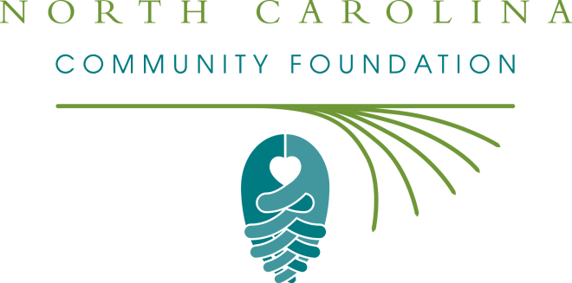

Northeast NC Coastal Research and Environmental Education Fund
2017 Grant Application

The Northeast NC Coastal Research and Environmental Education Fund will award grants for projects in coastal scientific research and/or environmental education in the northeastern counties of North Carolina. Proposals are due by noon on Tuesday, August 1, 2017.

Eligible proposals should be for a local northeast NC program, project, or environmental education outreach effort in one the following counties: Beaufort, Bertie, Camden, Chowan, Currituck, Dare, Gates, Hertford, Hyde, Martin, Pasquotank, Perquimans, Tyrrell or Washington.

Grant funding of $1,000 is available this year.

Please submit all applications electronically to:
Natalie Jenkins Peel
Northeastern Regional Director, NC Community Foundation
npeel@nccommunityfoundation.org

Northeast NC Coastal Research and Environmental Education Fund
2017 Grant Application

ORGANIZATION NAME EMPLOYER IDENTIFICATION NUMBER (EIN xx-xxxxxxx)

CONTACT PERSON (If not the Executive Officer of the organization, please specify that person as well.)

ADDRESS

PHONE NUMBER WEBSITE

EMAIL ADDRESS

Amount Requested

Brief Request Summary

Program/Project Begin Date

Program/Project End Date

Total Program/Project Budget

Activities/Operations
Please outline the specific activities and timetable of your program/project.

Staff, Volunteers, Partners
Who are the key staff or volunteers responsible, and what are their qualifications? List any collaborating organizations.

Goals and Objectives
What are the goals and measurable objectives that could be met with this funding support?

Evaluation Procedures
How will you measure success? Describe the evaluation process.

Digital Signature
By typing my name in the following space, I certify that I am an authorized representative of the charitable organization named in this application. I further certify that this application is submitted with the full knowledge and consent of the organization's Board of Directors or other governing body.

