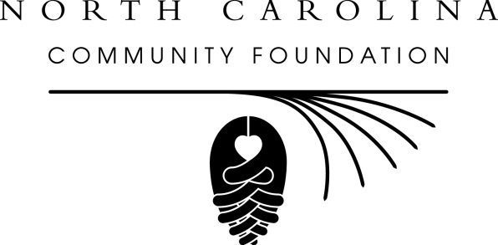 | The Mustard Seed Fund  A component fund of the  North Carolina Community Foundation, Inc.  2018 Mission  Scholarship Application

Background and award criteria
The Mustard Seed Fund was established in 2011 as a perpetual legacy to the memory of Wilmington residents Byron Stratas and Fred Rippy. The Endowment provides small grants to support high school or college students or adults from Southeastern North Carolina who are participating in mission trips through qualified 501(c)3 charities and faith-based organizations.

Note: The review committee will only consider applications for mission trips that begin after June 1, 2018.

Application packet (completed application and two letters of reference)

must be received by April 30, 2018.

Contact Information
Name
Mailing Address
City, State, Zip
Preferred Phone
E-Mail Address
School currently attending or
Occupation
If student, provide parent name(s)
Parent contact information

Mission Trip Information
Name of Mission Trip
Trip Dates
Name of Sponsoring Organization
Organization Mailing Address
Organization contact name
Contact’s telephone and email
Cost of this trip
Amount you already have
Other potential funding sources

Mission-Related Information
Special Skills and Talents: List any special skills or talents you have that you hope to use during this mission trip (eg. Medical, foreign language, teaching, construction, leadership, artistic, musical, etc.):

Essay

In five to eight sentences, please explain why you wish to participate in this mission trip and why you are applying for financial support.

References: Please attach two letters of reference to the completed application form. One of the letters should be from the local director of your mission trip. Letters should include the name, title, and contact information for the reference. The Review Committee will not consider late or incomplete applications. We will notify award recipients of their selection in May.

Please mail completed scholarship application and two letters of reference by April 30, 2018 to:
NCCF – Mustard Seed
1213 Culbreth Drive
Wilmington, NC 28405

Questions? Email bjenkins@nccommunityfoundation.org or call 919-256-6932 for information.

