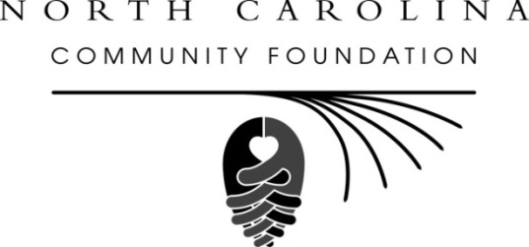
North Carolina Community Foundation names new CFO
For immediate release – Jan. 7, 2015
RALEIGH – The North Carolina Community Foundation (NCCF) has named David Ryan as its chief financial officer, according to Jennifer Tolle Whiteside, NCCF CEO and president. Ryan replaces John Berngartt, who retired at the end of 2014.
As CFO, Ryan has full management responsibilities for all financial matters of NCCF. He also leads human resources and information technology initiatives. He reports to Tolle Whiteside and is a member of NCCF’s leadership team.
Ryan brings a broad cross-functional background to NCCF that includes executive level positions in corporate finance and IT. He most recently served as co-founder and owner of an office supply and software company that was sold to a Fortune 300 competitor.
Tolle Whiteside said NCCF was fortunate to have attracted a professional with Ryan’s depth and breadth of experience to the expanded role of CFO. “We are so excited that David has joined our team and look forward to what his skills and deep professional experience will bring to the Foundation,” she said.
Originally from Athens, NY, Ryan attended Syracuse University where he received a bachelor’s degree in management. He received an MBA from Campbell University. He serves on the board of directors of Ten Thousand Villages in Raleigh.
About the North Carolina Community Foundation:
The NCCF is the single statewide community foundation serving North Carolina and has made $89 million in grants since its inception in 1988. With more than $191 million in assets at fiscal year-end March 31, 2014, the NCCF sustains 1,200 endowments established to provide long-term support of a broad range of community needs, nonprofit organizations, institutions and scholarships. NCCF partners with 60 affiliate foundations to provide local resource allocation and community assistance in 67 counties across the state. An important component of the NCCF’s mission is to ensure that rural philanthropy has a voice at local, regional and national levels.
For more information, visit nccommunityfoundation.org and Facebook and follow us on Twitter @NCCF.
END
NEWS MEDIA CONTACT:
Noel McLaughlin, NCCF Director of Marketing and Communications
nmclaughlin@nccommunityfoundation.org
919-256-6901

